**Normalization**

1. **Make** (CH_ID CH_NAME, ADDRESS, COUNTRY, CITY, I_NAME, I_FLAVOUR, I_PRICE, I_QUNTITY)

**1NF**: I_PRICE multivalued attribute

**2NF:** CH_ID, CH_NAME, ADDRESS, COUNTRY, CITY

I_NAME, I_FLAVOUR, I_PRICE, I_QUNTITY, CH_ID,

**3NF**: CH_ID, CH_NAME, ADDRESS

I_NAME, I_FLAVOUR, I_PRICE, I_QUNTITY, CH_ID

A_ID, COUNTRY, CITY

**TABLE**

1. CH_ID, CH_NAME, ADDRESS,
2. I_NAME, I_FLAVOUR, I_PRICE, I_QUNTITY, CH_ID
3. A_ID, COUNTRY, CITY

1. **SUPPLY** (I_NAME, I_FLAVOUR, I_PRICE, I_QUNTITY, SUP_ID, SUP_NAME, SUP_QUNTITY)

1NF: I_PRICE multivalued attribute

2NF: I_NAME, I_FLAVOUR, I_PRICE, I_QUNTITY

SUP_ID, SUP_NAME, SUP_QUNTITY, I_NAME

3NF: I_NAME, I_FLAVOUR, I_PRICE, I_QUNTITY

SUP_ID, SUP_NAME, SUP_QUNTITY, I_NAME

Table

1. I_NAME, I_FLAVOUR, I_PRICE, I_QUNTITY
2. SUP_ID, SUP_NAME, SUP_QUNTITY,I_NAME

1. **SERVE** (I_NAME, I_FLAVOUR, I_PRICE, I_QUNTITY, W_ID, W_NAME, W_PHONE, SALARY)

1NF: W_PHONE multivalued attribute

2NF:I_NAME, I_FLAVOUR, I_PRICE, I_QUNTITY

W_ID, W_NAME, W_PHONE, W_SALARY, I_NAME

3NF: I_NAME, I_FLAVOUR, I_PRICE, I_QUNTITY

W_ID, W_NAME, W_PHONE, SALARY, I_NAME

TABLE:

1. I_NAME, I_FLAVOUR, I_PRICE, I_QUNTITY
2. W_ID, W_NAME, W_PHONE, SALARY, I_NAME
3. **WORKS FOR** (W_ID, W_NAME, W_PHONE, SALARY, M_ID, M_NAME, M_PHONE)

1NF: M_PHONE multivalued attribute

2NF: W_ID, W_NAME, W_PHONE, SALARY

M_ID, M_NAME, M_PHONE, W_ID

3NF: W_ID, W_NAME, W_PHONE, SALARY

M_ID, M_NAME, M_PHONE, W_ID

TABLE:

1. W_ID, W_NAME, W_PHONE, SALARY
2. M_ID, M_NAME, M_PHONE, W_ID
3. **CONTROLS** (M_ID, M_NAME, M_PHONE, O_ID, O_PHONE )

1NF: O_PHONE multivalued attribute

2NF: M_ID, M_NAME, M_PHONE, O_ID

O_ID, O_PHONE

3NF: M_ID, M_NAME, M_PHONE, O_ID

O_ID, O_PHONE

TABLE:

1. O_ID, O_PHONE
2. M_ID, M_NAME, M_PHONE, O_ID
3. **HIRE** (M_ID, M_NAME, M_PHONE, O_ID, O_PHONE )

1NF: O_PHONE multivalued attribute

2NF: M_ID, M_NAME, M_PHONE, O_ID

O_ID, O_PHONE

3NF: M_ID, M_NAME, M_PHONE

O_ID, O_PHONE, M_ID

TABLE:

1. O_ID, O_PHONE, M_ID
2. M_ID, M_NAME, M_PHONE
3. **PAY** (O_ID, O_PHONE, W_ID, W_NAME, W_PHONE, SALARY)

1NF: O_PHONE multivalued attribute

2NF: O_ID, O_PHONE

W_ID, W_NAME, W_PHONE, SALARY, O_ID

3NF: O_ID, O_PHONE

W_ID, W_NAME, W_PHONE, SALARY, O_ID

TABLE:

1. O_ID, O_PHONE
2. W_ID, W_NAME, W_PHONE, SALARY, O_ID
3. **OWN** (O_ID, O_PHONE, S_ID, S_ADD, CITY, COUNTRY)

1NF: O_PHONE multivalued attribute

2NF: O_ID, O_PHONE, S_ID

S_ID, S_ADD, CITY, COUNTRY

3NF: O_ID, O_PHONE, S_ID

S_ID, S_ADD

A_ID, CITY, COUNTRY

TABLE:

1. O_ID, O_PHONE, S_ID
2. S_ID, S_ADD
3. A_ID, CITY, COUNTRY

1. **SELECT** (C_ID, C_NAME, C_ADD, C_PHONE, I_NAME, I_FLAVOUR, I_PRICE, I_QUNTITY)

1NF: C_PHONE multivalued attribute

2NF: C_ID, C_NAME, C_ADD, C_PHONE, I_NAME

I_NAME, I_FLAVOUR, I_PRICE, I_QUNTITY

3NF: C_ID, C_NAME, C_ADD, C_PHONE, I_NAME

I_NAME, I_FLAVOUR, I_PRICE, I_QUNTITY

TABLE:

1. C_ID, C_NAME, C_ADD, C_PHONE, I_NAME
2. I_NAME, I_FLAVOUR, I_PRICE, I_QUNTITY
3. **ORDER BY** (C_ID, C_NAME, C_ADD, C_PHONE, W_ID, W_NAME, W_PHONE, SALARY)

1NF: C_PHONE, W_PHONE are multivalued attribute

2NF: C_ID, C_NAME, C_ADD, C_PHONE

W_ID, W_NAME, W_PHONE, SALARY, C_ID

3NF: C_ID, C_NAME, C_ADD, C_PHONE

W_ID, W_NAME, W_PHONE, SALARY, C_ID

TABLE:

1. C_ID, C_NAME, C_ADD, C_PHONE
2. W_ID, W_NAME, W_PHONE, SALARY, C_ID
3. **PAYS** (C_ID, C_NAME, C_ADD, C_PHONE, B_NUMBER , AMOUNT, TIME )

1NF: C_PHONE multivalued attribute

2NF: C_ID, C_NAME, C_ADD, C_PHONE

B_NUMBER, AMOUNT, TIME, C_ID

3NF: C_ID, C_NAME, C_ADD, C_PHONE

B_NUMBER, AMOUNT, TIME, C_ID

TABLE:

1. C_ID, C_NAME, C_ADD, C_PHONE
2. B_NUMBER , AMOUNT, TIME, C_ID
3. **RECEIVED** (B_NUMBER, AMOUNT, TIME, CA_ID ,CA_NAME, CITY, COUNTRY)

1NF: No Multivalued attribute

2NF: B_NUMBER, AMOUNT, TIME, CA_ID

CA_ID ,CA_NAME, CITY, COUNTRY

3NF: B_NUMBER, AMOUNT, TIME, CA_ID

CA_ID, CA_NAME

A_ID, CITY, COUNTRY

TABLE:

1. B_NUMBER, AMOUNT, TIME, CA_ID
2. CA_ID ,CA_NAME
3. A_ID, CITY, COUNTRY

**TOTAL TABLE**

1. CH_ID, CH_NAME, ADDRESS
2. I_NAME, I_FLAVOUR, I_PRICE, I_QUNTITY, CH_ID
3. ~~A_ID, COUNTRY, CITY~~
4. ~~I_NAME, I_FLAVOUR, I_PRICE, I_QUNTITY~~
5. SUP_ID, SUP_NAME, SUP_QUNTITY,I_NAME
6. ~~I_NAME, I_FLAVOUR, I_PRICE, I_QUNTITY~~
7. W_ID, W_NAME, W_PHONE, SALARY, I_NAME
8. ~~W_ID, W_NAME, W_PHONE, SALARY~~
9. M_ID, M_NAME, M_PHONE, W_ID
10. ~~O_ID, O_PHONE~~
11. M_ID, M_NAME, M_PHONE, O_ID
12. O_ID, O_PHONE, M_ID
13. ~~M_ID, M_NAME, M_PHONE~~
14. ~~O_ID, O_PHONE~~
15. W_ID, W_NAME, W_PHONE, SALARY, O_ID
16. O_ID, O_PHONE, S_ID
17. S_ID, S_ADD
18. A_ID, CITY, COUNTRY
19. C_ID, C_NAME, C_ADD, C_PHONE, I_NAME
20. ~~I_NAME, I_FLAVOUR, I_PRICE, I_QUNTITY~~
21. ~~C_ID, C_NAME, C_ADD, C_PHONE~~
22. B_NUMBER , AMOUNT, TIME, C_ID
23. B_NUMBER, AMOUNT, TIME, CA_ID
24. CA_ID ,CA_NAME
25. ~~A_ID, CITY, COUNTRY~~

**FINAL TABLE**

1. CH_ID, CH_NAME, ADDRESS
2. I_NAME, I_FLAVOUR, I_PRICE, I_QUNTITY, CH_ID
3. SUP_ID, SUP_NAME, SUP_QUNTITY,I_NAME
4. W_ID, W_NAME, W_PHONE, SALARY, I_NAME
5. M_ID, M_NAME, M_PHONE, W_ID
6. M_ID, M_NAME, M_PHONE, O_ID
7. O_ID, O_PHONE, M_ID
8. W_ID, W_NAME, W_PHONE, SALARY, O_ID
9. O_ID, O_PHONE, S_ID
10. S_ID, S_ADD
11. A_ID, CITY, COUNTRY
12. C_ID, C_NAME, C_ADD, C_PHONE, I_NAME
13. B_NUMBER , AMOUNT, TIME, C_ID
14. B_NUMBER, AMOUNT, TIME, CA_ID
15. CA_ID ,CA_NAME
16. create table Chef

(CH_ID NUMBER(10) constraint Chef_pk Primary key,

CH_NAME VARCHAR2(25),

ADDRESS VARCHAR2(25))

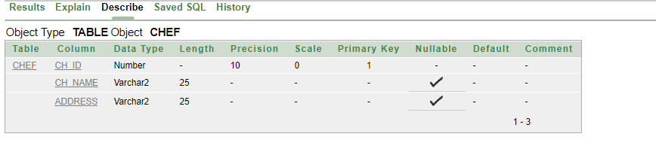

1. create table ICE_CREAM

(I_NAME VARCHAR2(25) constraint ICE_pk Primary key,

I_FLAVOUR VARCHAR2(25),

I_PRICE VARCHAR2(25),

I_QUANTITY VARCHAR2(25),

CH_ID NUMBER (10) CONSTRAINT ICE_FK REFERENCES CHEF(CH_ID))

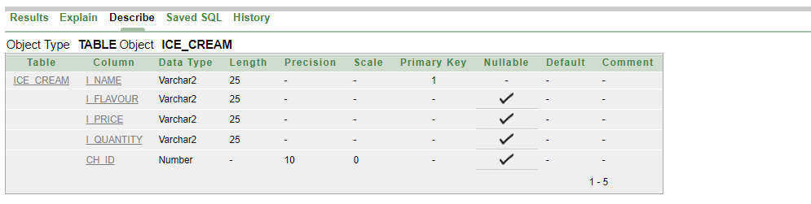

1. create table SUPPLY

(SUP_ID NUMBER(10) CONSTRAINT SUPPLY_PK PRIMARY KEY,

SUP_NAME VARCHAR2(25) DEFAULT 'ER GROUP',

SUP_QUANTITY NUMBER(7),

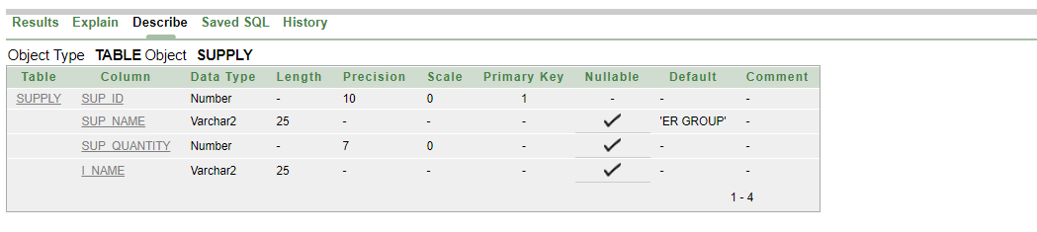 I_NAME VARCHAR2(25) CONSTRAINT SUPPLY_FK REFERENCES ICE_CREAM(I_NAME))

1. create table WAITER

(W_ID NUMBER(10) CONSTRAINT WAITER_PK PRIMARY KEY,

W_NAME VARCHAR2(25),

W_PHONE NUMBER(11),

SALARY NUMBER (7),

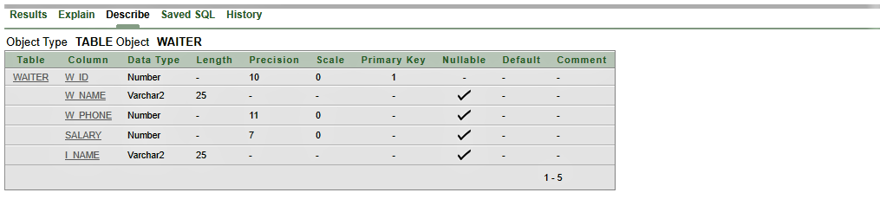 I_NAME VARCHAR2(25) CONSTRAINT WAITER_FK REFERENCES ICE_CREAM(I_NAME))

1. create table Manager

(M_ID number(10) constraint Manager_pk Primary key,

M_name varchar2(25),

M_phone number(11),

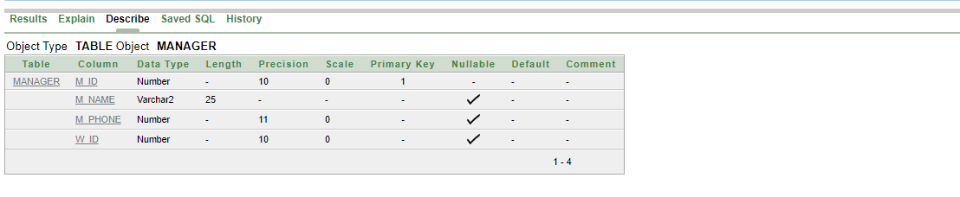 W_ID number(10) constraint manager_fk references Waiter(w_id))

1. create table OWNER

(O_ID number(10) constraint Owner_pk primary key,

O_Phone number(11),

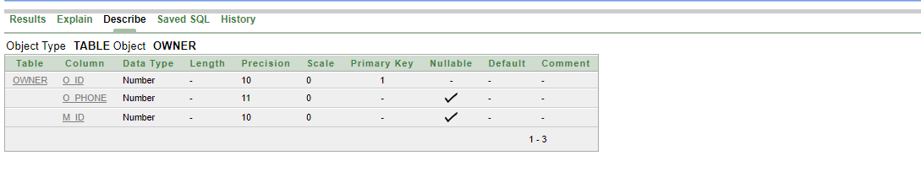 M_ID number(10) constraint owner_fk references Manager(M_ID))

1. create table Manager_Owner

(M_ID number(10) constraint Man_pk Primary key,

M_NAME varchar2(25),

M_PHONE number(11),

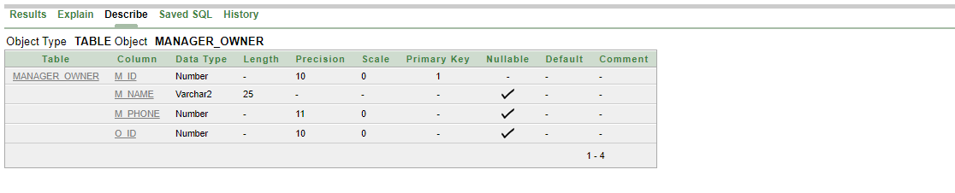 O_ID NUMBER(10) constraint man_fk references Owner(O_ID))

1. create table Waiter_owner

(W_ID number(10) constraint wait_pk Primary key,

W_name varchar2(25),

W_Phone number(11),

salary number(5),

O_ID number(10) constraint wait_fk references owner(o_id))

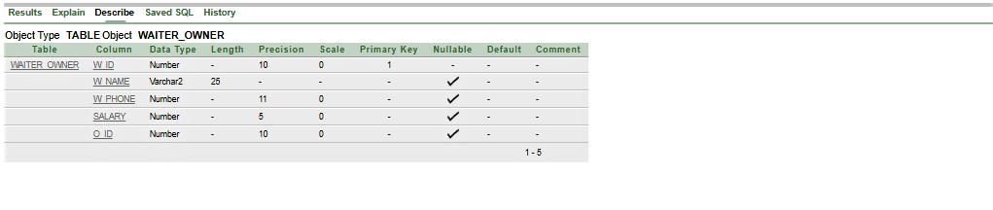

1. create table shop

(s_id number(10) constraint shop_pk primary key,

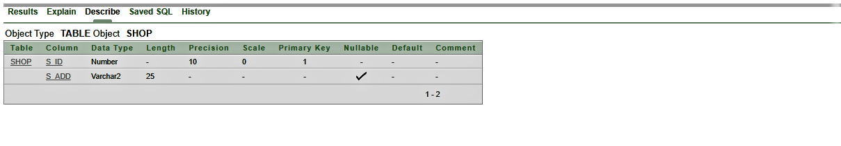 s_add varchar2(25))

10. create table owner_shop

(O_ID number(10) constraint Ownshop_pk primary key,

O_Phone number(11),

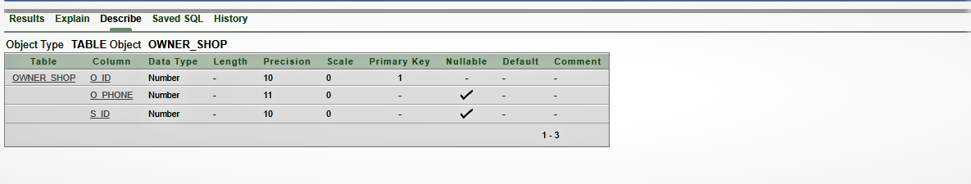 s_id number(10) constraint ownshop_fk references shop(s_id))

1. create table Area

(a_id number(10) constraint area_pk primary key,

city varchar2(25),

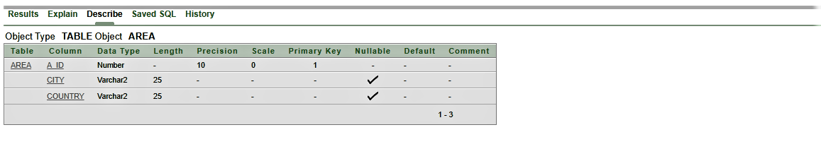 country varchar2(25))

12. create table Customer

(c_id number(10) constraint customer_pk primary key,

C_name varchar2(25),

c_add varchar2(25),

c_phone number(11),

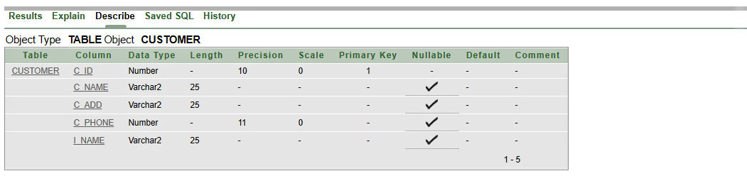 i_name varchar2(25) constraint customer_fk references Ice_cream(i_name))

1. create table bill

(b_number number(10) constraint bill_pk primary key,

amount number(5),

time number(4,2),

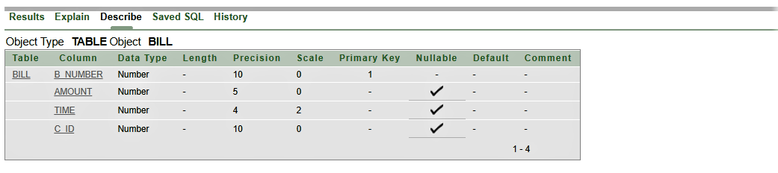 c_id number(10) constraint bill_fk references customer(c_id))

1. create table cashier

(ca_id number(10) constraint cashier_pk primary key,

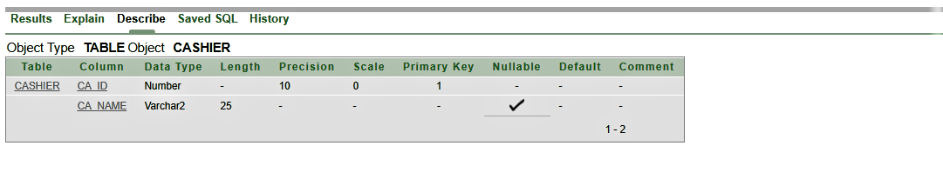 ca_name varchar2(25))

1. create table cashier_bill

(b_number number(10) constraint cashbill_pk primary key,

amount number(5),

time number(4,2),

ca_id number(10) constraint cashier_Fk references cashier(ca_id))

